**First thing first**

You can have a very successful career without ever knowing about it’s existence in javascript.

It is mostly handy to use break; and continue; statements

But in normal cases we don’t need labels to use break and continue statements

But labels can be handy while working in nested loops

See

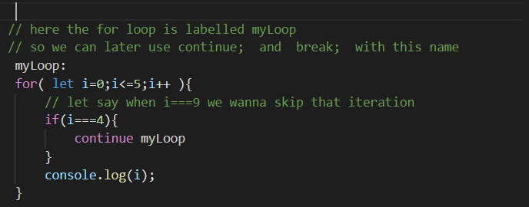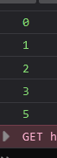

But label is mostly used in nested loops

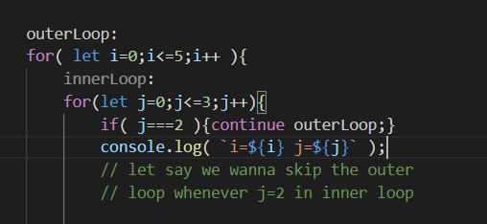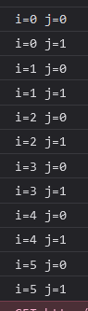

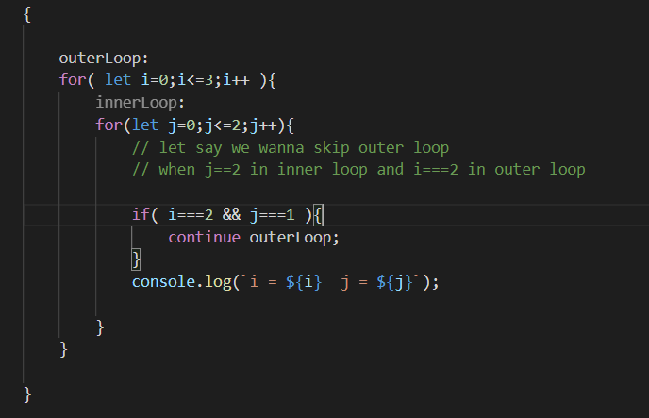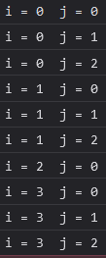

Look carefully



I ko value 2 hudaa j ko value 0 matrai print vayo,

Next iteration maa j ko value 1 hunxaa ani tyo bela we skipped the iteration of outer loop so 1 paxi j ko further value print hudainaa

can refer to this article

<https://css-tricks.com/you-can-label-a-javascript-if-statement/>